**ASSIGNMENT -1 (ADVANCED PROGRAMMING)**

1. **Problem 1:** Longest Nice Substring
2. **Implementation/Code:**

class Solution {

public String longestNiceSubstring(String s) {

if (s.length() < 2)

return "";

for (int i = 0; i < s.length(); i++) {

char ch = s.charAt(i);

if (s.contains(Character.toString(Character.toLowerCase(ch))) &&

s.contains(Character.toString(Character.toUpperCase(ch)))) {

continue; }

String left = longestNiceSubstring(s.substring(0, i));

String right = longestNiceSubstring(s.substring(i + 1));

return left.length() >= right.length() ? left : right;

}

return s; }}

**Output:** 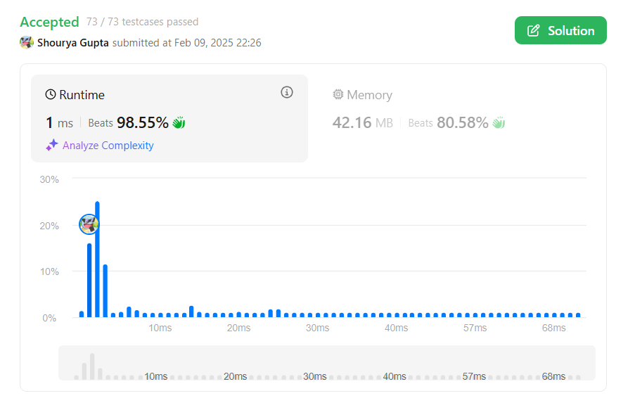

1. **Problem 2:** Reverse Bits
2. **Implementation/Code:**

public class Solution {

public int reverseBits(int n) {

int reversed = 0;

for (int i = 0; i < 32; i++) {

reversed = (reversed << 1) | (n & 1);

n >>>= 1;

}

return reversed;

}

}

1. **Output:**

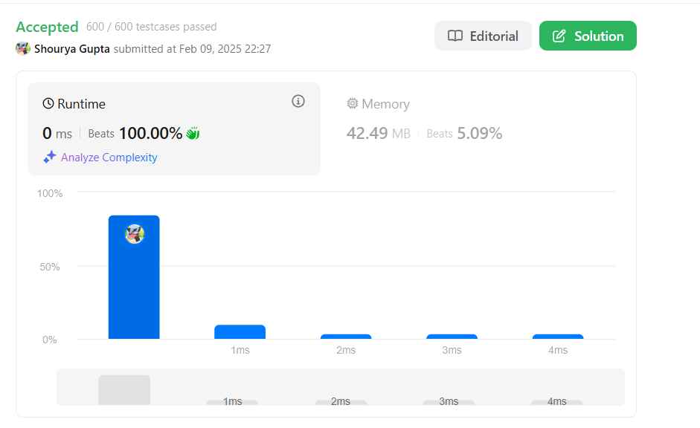

1. **Problem 3:** Number of 1 bits
2. **Implementation/code:**

public class Solution {

public int hammingWeight(int n) {

int count = 0;

while (n != 0) {

count += (n & 1);

n >>>= 1;

}

return count;

}

}

1. **Output:**

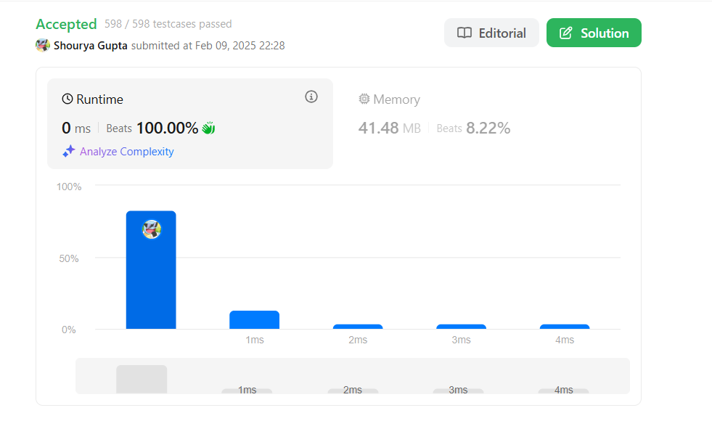

1. **Problem 4: Maximum Sub array**
2. **Implementation/code:**

public class Solution {

public int maxSubArray(int[] nums) {

int maxSum = nums[0], currentSum = 0;

for (int num : nums) {

currentSum = Math.max(num, currentSum + num);

maxSum = Math.max(maxSum, currentSum);

}

return maxSum;

}

}

1. **Output:**



1. **Problem 5: Search a 2D Matrix II**
2. **Implementation/Code:**

public class Solution {

public boolean searchMatrix(int[][] matrix, int target) {

int rows = matrix.length, cols = matrix[0].length;

int row = 0, col = cols - 1;

while (row < rows && col >= 0) {

if (matrix[row][col] == target) {

return true;

} else if (matrix[row][col] < target) {

row++;

} else {

col--; }

}

return false;

}}

1. **Output:**

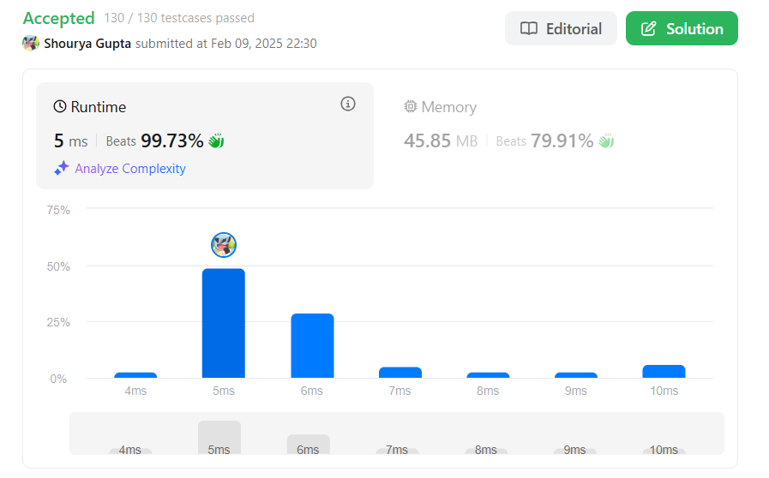

1. **Problem 6: Super Pow**
2. **Implementation/Code:**

public class Solution {

private static final int MOD = 1337;

private int pow(int a, int b) {

int res = 1;

a %= MOD;

for (int i = 0; i < b; i++) {

res = (res * a) % MOD; }

return res; }

public int superPow(int a, int[] b) {

int res = 1;

for (int i = b.length - 1; i >= 0; i--) {

res = (res * pow(a, b[i])) % MOD;

a = pow(a, 10);

}

return res; }}

1. **Output:**

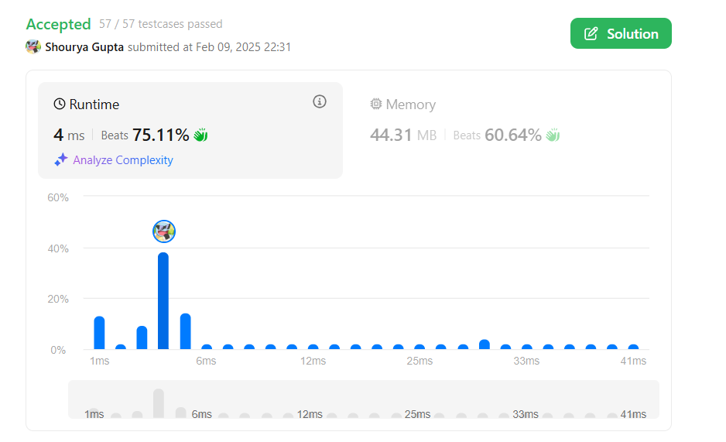

1. **Problem 7: Beautiful Array**
2. **Implementation/code:**

import java.util.*;

public class Solution {

public int[] beautifulArray(int N) {

List<Integer> result = new ArrayList<>();

result.add(1);

while (result.size() < N) {

List<Integer> temp = new ArrayList<>();

for (int num : result) {

if (num * 2 - 1 <= N) temp.add(num * 2 - 1); }

for (int num : result) {

if (num * 2 <= N) temp.add(num * 2); }

result = temp; }

int[] arr = new int[result.size()];

for (int i = 0; i < result.size(); i++) {

arr[i] = result.get(i); }

return arr; }}

1. **Output:**

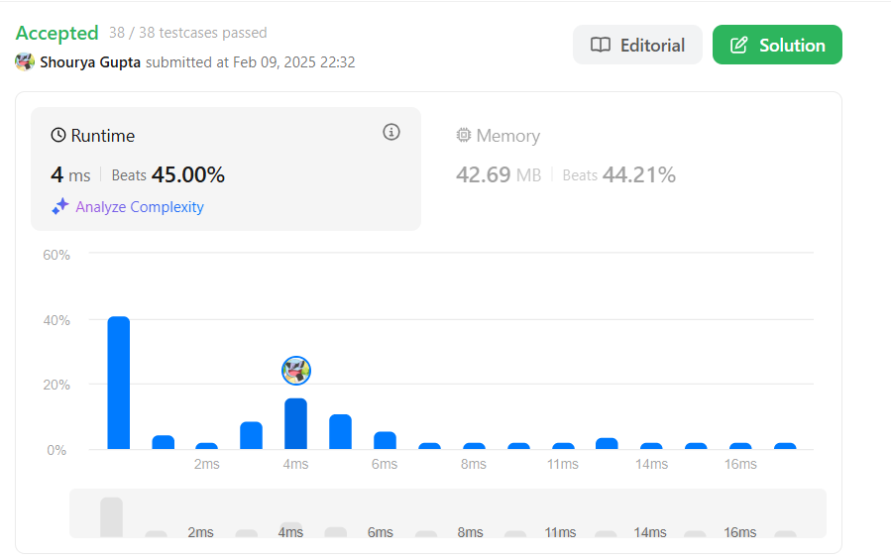

1. **Problem 8: The Skyline Problem.**
2. **Implementation/code:**

import java.util.*;

class Solution {

public List<List<Integer>> getSkyline(int[][] buildings) {

return divideAndConquer(buildings, 0, buildings.length - 1); }

private List<List<Integer>> divideAndConquer(int[][] buildings, int left, int right) {

if (left > right) return new ArrayList<>();

if (left == right) {

List<List<Integer>> result = new ArrayList<>();

result.add(Arrays.asList(buildings[left][0], buildings[left][2]));

result.add(Arrays.asList(buildings[left][1], 0));

return result; }

int mid = left + (right - left) / 2;

List<List<Integer>> leftSkyline = divideAndConquer(buildings, left, mid);

List<List<Integer>> rightSkyline = divideAndConquer(buildings, mid + 1, right);

return mergeSkylines(leftSkyline, rightSkyline); }

private List<List<Integer>> mergeSkylines(List<List<Integer>> left, List<List<Integer>> right) {

List<List<Integer>> result = new ArrayList<>();

int h1 = 0, h2 = 0, i = 0, j = 0;

while (i < left.size() && j < right.size()) {

List<Integer> point1 = left.get(i);

List<Integer> point2 = right.get(j); int x;

if (point1.get(0) < point2.get(0)) {

x = point1.get(0);

h1 = point1.get(1);

i++;

} else if (point1.get(0) > point2.get(0)) {

x = point2.get(0);

h2 = point2.get(1);

j++;

} else {

x = point1.get(0);

h1 = point1.get(1);

h2 = point2.get(1);

i++;

j++; }

int maxHeight = Math.max(h1, h2);

if (result.isEmpty() || result.get(result.size() - 1).get(1) != maxHeight) { result.add(Arrays.asList(x, maxHeight)); } }

while (i < left.size()) result.add(left.get(i++));

while (j < right.size()) result.add(right.get(j++));

return result;

}

}

1. **Output:**

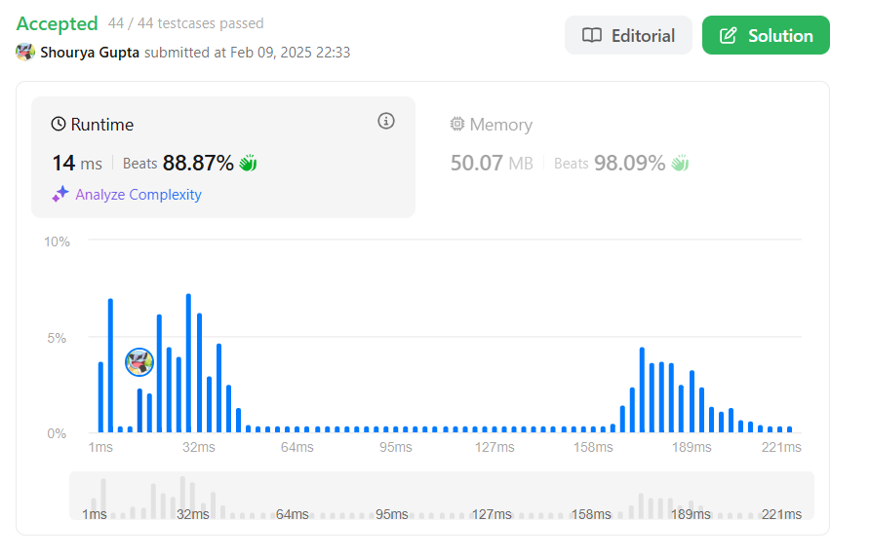

1. **Problem 9: Reverse Pairs**
2. **Implementation/code:**

public class Solution {

public int reversePairs(int[] nums) {

return mergeSort(nums, 0, nums.length - 1);

}

private int mergeSort(int[] nums, int left, int right) {

if (left >= right) return 0;

int mid = left + (right - left) / 2;

int count = mergeSort(nums, left, mid) + mergeSort(nums, mid + 1, right);

int j = mid + 1;

for (int i = left; i <= mid; i++) {

while (j <= right && (long)nums[i] > 2 * (long)nums[j]) {

j++;

}

count += j - (mid + 1);

}

merge(nums, left, mid, right);

return count;

}

private void merge(int[] nums, int left, int mid, int right) {

int[] temp = new int[right - left + 1];

int i = left, j = mid + 1, k = 0;

while (i <= mid && j <= right) {

if (nums[i] <= nums[j]) {

temp[k++] = nums[i++];

} else {

temp[k++] = nums[j++];

}

}

while (i <= mid) temp[k++] = nums[i++];

while (j <= right) temp[k++] = nums[j++];

System.arraycopy(temp, 0, nums, left, temp.length);

}

}

1. **Output:**

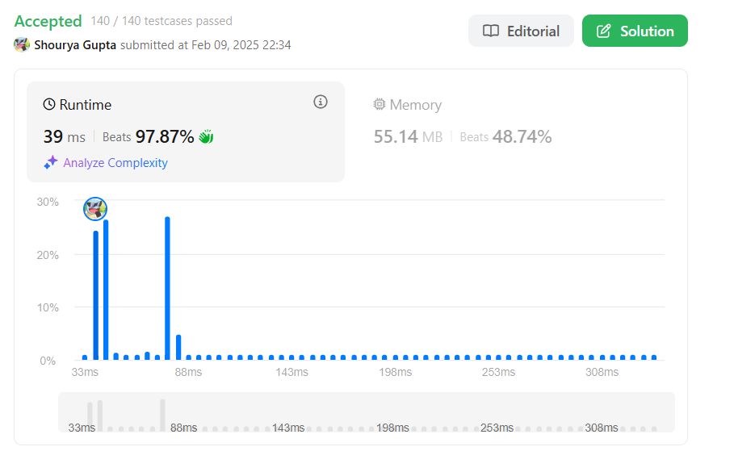

1. **Problem 10: Longest Increasing SubSequence**
2. **Implementation/Code:**

class Solution {

int N = 100001;

int[] seg = new int[2 * N];

void update(int pos, int val) {

pos += N;

seg[pos] = val;

while (pos > 1) {

pos >>= 1;

seg[pos] = Math.max(seg[2 * pos], seg[2 * pos + 1]);

}

}

int query(int lo, int hi) {

lo += N;

hi += N;

int res = 0;

while (lo < hi) {

if ((lo & 1) == 1) {

res = Math.max(res, seg[lo++]);

}

if ((hi & 1) == 1) {

res = Math.max(res, seg[--hi]);

}

lo >>= 1;

hi >>= 1;

}

return res;

}

public int lengthOfLIS(int[] A, int k) {

int result = 0;

for (int i = 0; i < A.length; ++i) {

int l = Math.max(0, A[i] - k);

int r = A[i];

int current = query(l, r) + 1;

result = Math.max(result, current);

update(A[i], current);

}

return result;

}

}

1. **Output:**

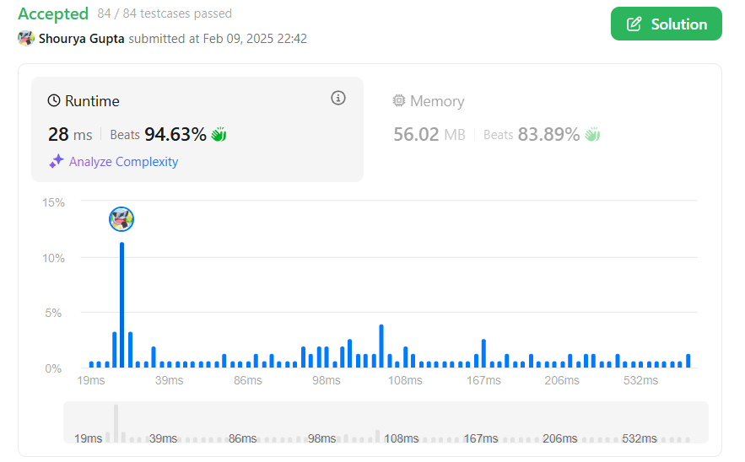

1. **Problem 11: Merge Sorted Array**
2. **Implementation/Code:**

public class Solution {

public void merge(int[] nums1, int m, int[] nums2, int n) {

int p1 = m - 1, p2 = n - 1, p = m + n - 1;

while (p1 >= 0 && p2 >= 0) {

if (nums1[p1] > nums2[p2]) {

nums1[p] = nums1[p1];

p1--;

} else {

nums1[p] = nums2[p2];

p2--;

}

p--;

}

while (p2 >= 0) {

nums1[p] = nums2[p2];

p2--;

p--; } }}

1. **Output:**

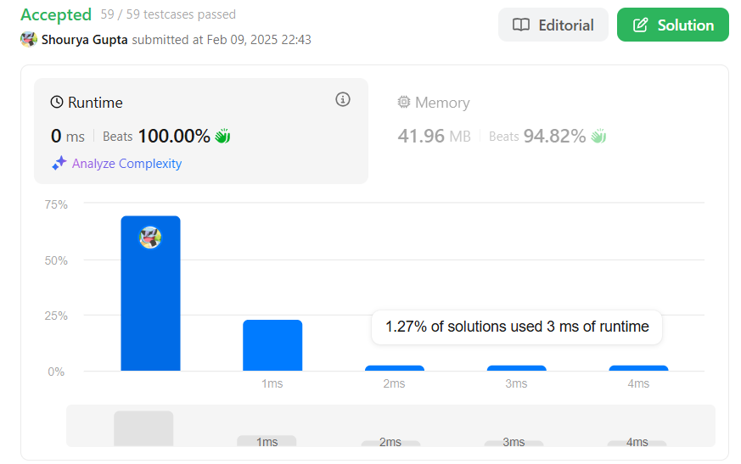

1. **Problem 12: First Bad Version**
2. **Code:**

public class Solution extends VersionControl {

public int firstBadVersion(int n) {

int left = 1, right = n;

while (left < right) {

int mid = left + (right - left) / 2;

if (isBadVersion(mid)) {

right = mid;

} else {

left = mid + 1;

} }

return left; }}

1. **Output:**

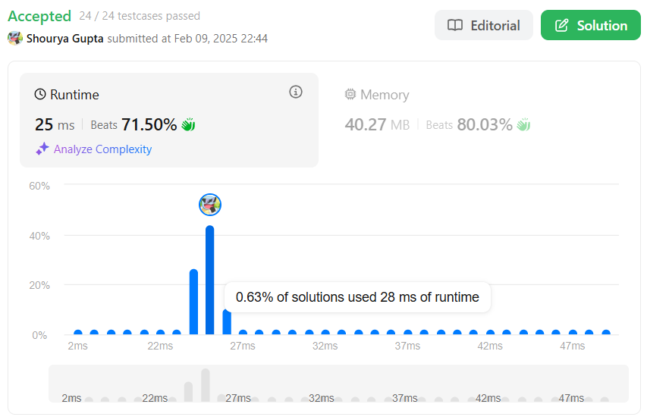

1. **Problem 13: Sort Colors**
2. **Code:**

class Solution {

public void sortColors(int[] nums) {

int low = 0, mid = 0, high = nums.length - 1;

while (mid <= high) {

if (nums[mid] == 0) {

swap(nums, low++, mid++);

} else if (nums[mid] == 1) {

mid++;

} else {

swap(nums, mid, high--);

} } }

private void swap(int[] nums, int i, int j) {

int temp = nums[i];

nums[i] = nums[j];

nums[j] = temp;

}

}

1. **Output:**

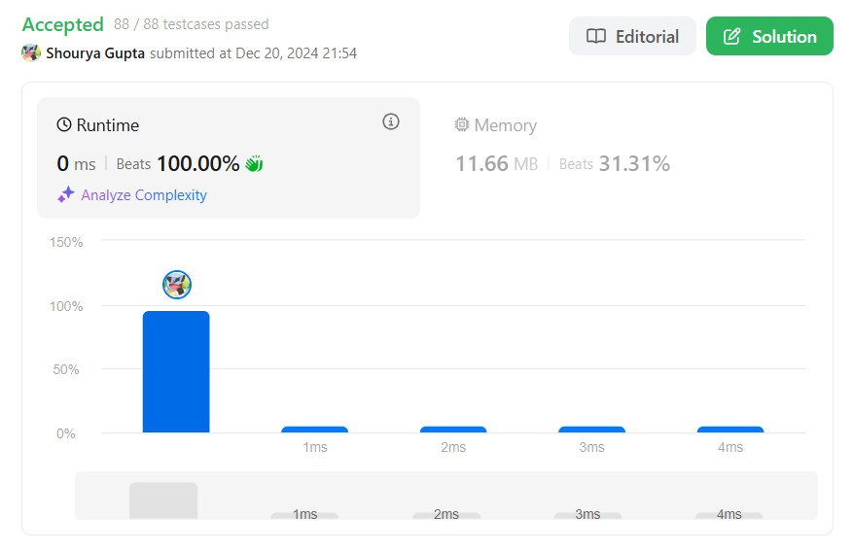

1. **Problem 14: Top K frequent Elements**
2. **Code:**

import java.util.*;

class Solution {

public int[] topKFrequent(int[] nums, int k) {

Map<Integer, Integer> freqMap = new HashMap<>();

for (int num : nums) freqMap.put(num, freqMap.getOrDefault(num, 0) + 1);

List<Integer> list = new ArrayList<>(freqMap.keySet());

list.sort((a, b) -> freqMap.get(b) - freqMap.get(a));

int[] result = new int[k];

for (int i = 0; i < k; i++) result[i] = list.get(i);

return result;

}

}

1. **Output:**

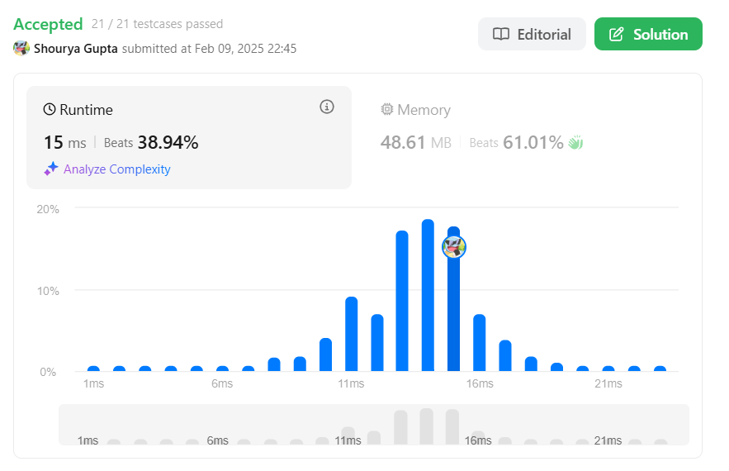

1. **Problem 15:** [Kth Largest Element in an Array](https://leetcode.com/problems/kth-largest-element-in-an-array/description/)
2. **Code:**

class Solution {

public int findKthLargest(int[] nums, int k) {

int n = nums.length;

int[] b = new int[n];

int j = 0;

for (int i = n - 1; i >= 0; i--) {

b[j] = nums[i];

j++;

}

Arrays.sort(b);

return b[n - k];

}

}

1. **Output:**

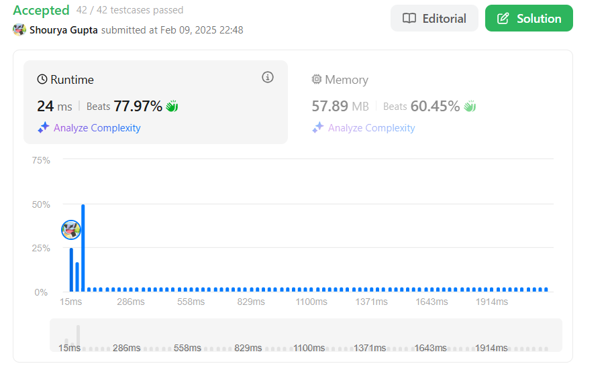

1. **Problem 16: Find Peak Element**
2. **Code:**

class Solution {

public int findPeakElement(int[] nums) {

int left = 0, right = nums.length - 1;

while (left < right) {

int mid = (left + right) / 2;

if (nums[mid] > nums[mid + 1]) right = mid;

else left = mid + 1;

}

return left;

}

}

1. **Output:**

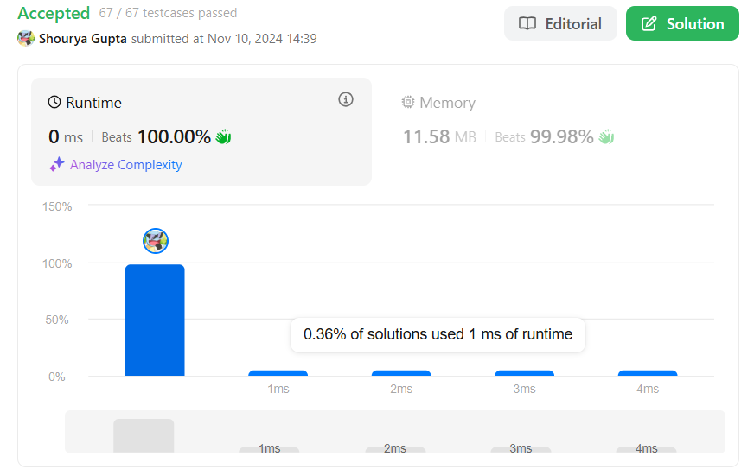

1. **Problem 17: Merge Intervals**
2. **Code:**

import java.util.*;

class Solution {

public int[][] merge(int[][] intervals) {

Arrays.sort(intervals, new Comparator<int[]>() {

public int compare(int[] a, int[] b) {

return a[0] - b[0];

}

});

List<int[]> result = new ArrayList<>();

for (int[] interval : intervals) {

if (result.isEmpty() || result.get(result.size() - 1)[1] < interval[0]) {

result.add(interval);

} else {

result.get(result.size() - 1)[1] = Math.max(result.get(result.size() - 1)[1], interval[1]);

} }

return result.toArray(new int[result.size()][]);

}}

1. **Output:**

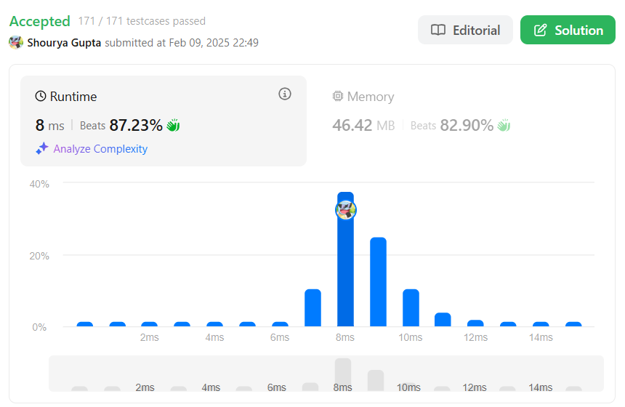

1. **Problem 18: Search in rotated Sorted Array**
2. **Code:**

class Solution {

public int search(int[] nums, int target) {

int left = 0, right = nums.length - 1;

while (left <= right) {

int mid = (left + right) / 2;

if (nums[mid] == target) return mid;

if (nums[left] <= nums[mid]) {

if (nums[left] <= target && target < nums[mid]) right = mid - 1;

else left = mid + 1;

} else {

if (nums[mid] < target && target <= nums[right]) left = mid + 1;

else right = mid - 1;

} }

return -1; }}

1. **Output:**

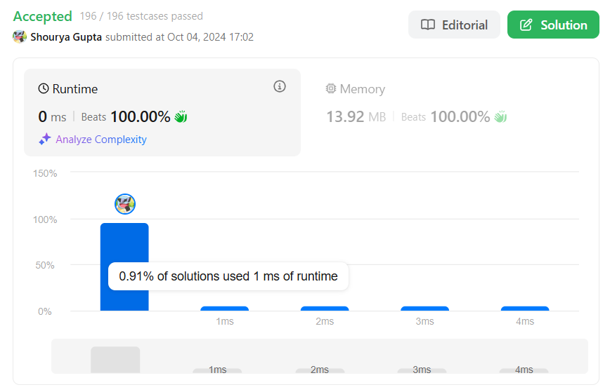

1. **Problem 19: Wiggle Sort II**
2. **Code:**

class Solution {

public void wiggleSort(int[] nums) {

int n=nums.length-1;

int[] newarr=Arrays.copyOf(nums,nums.length);

Arrays.sort(newarr);

for(int i=1;i<nums.length;i+=2)

nums[i]=newarr[n--];

for(int i=0;i<nums.length;i+=2)

nums[i]=newarr[n--];

}

}

1. **Output:**

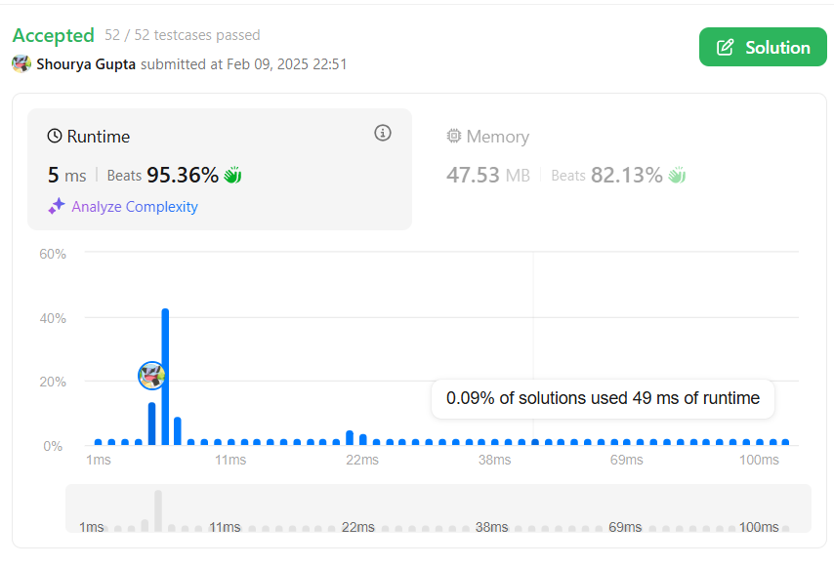

1. **Problem 20: Kth Smallest Element** [**in a Sorted Matrix**](https://leetcode.com/problems/kth-smallest-element-in-a-sorted-matrix/description/)
2. **Code:**

import java.util.*;

class Solution {

public int kthSmallest(int[][] matrix, int k) {

int n = matrix.length;

int m = matrix[0].length;

List<Integer> p = new ArrayList<>();

for (int i = 0; i < n * m; i++) {

p.add(matrix[i / m][i % m]);

}

Collections.sort(p);

return p.get(k - 1);

}

}

1. **Output:**

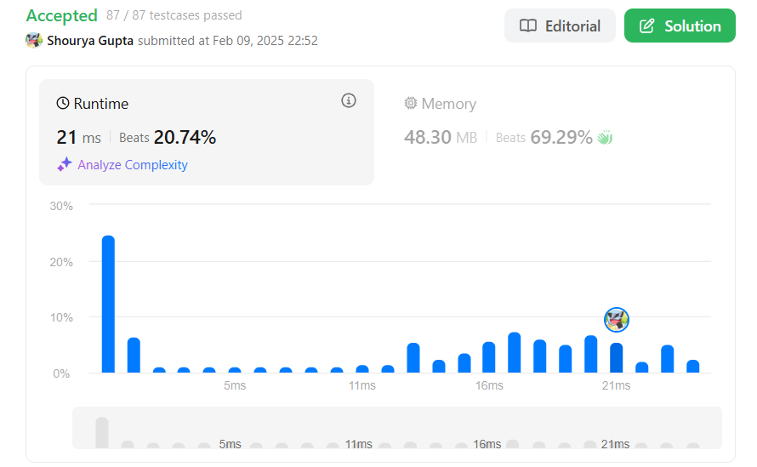

1. **Problem 21: Median of Two Sorted Arrays.**
2. **Code:**

import java.util.Arrays;

class Solution {

public double findMedianSortedArrays(int[] nums1, int[] nums2) {

int n = nums1.length;

int m = nums2.length;

int[] merged = new int[n + m];

int k = 0;

for (int i = 0; i < n; i++) { merged[k++] = nums1[i]; }

for (int i = 0; i < m; i++) { merged[k++] = nums2[i]; }

Arrays.sort(merged);

int total = merged.length;

if (total % 2 == 1) {

return (double) merged[total / 2];

} else {

int middle1 = merged[total / 2 - 1];

int middle2 = merged[total / 2];

return ((double) middle1 + (double) middle2) / 2.0; } }}

1. **Output:**

